**Chapter 7 - Nitrogen, Sulfur, and Metals**

**All Lectures Uploaded on YouTube:**

[**https://tinyurl.com/fkm10-chemistry**](https://tinyurl.com/fkm10-chemistry)



Nitrogen and sulphur oxides play important roles in the environment and industrial processes. For instance, in the atmosphere, oxides such as nitric oxide (NO) and nitrogen dioxide (NOz) react with unburned hydrocarbons, resulting in the formation of peroxy acetyl nitrate, or PAN, which is a major component of photochemical smog.

**7.1. Photochemical Smog**

*A type of air pollution formed when sunlight reacts with nitrogen oxides (NOₓ) and volatile organic compounds (VOCs) in the atmosphere.*

**Key Component: Peroxyacetyl Nitrate (PAN)** - A major component and secondary pollutant in smog.

**Formation Process (Step-by-Step):**

1. **Formation of NO₂:**

Nitric oxide (NO) from vehicles and industry reacts with oxygen. *2NO(g) + O₂(g) → 2NO₂(g)*

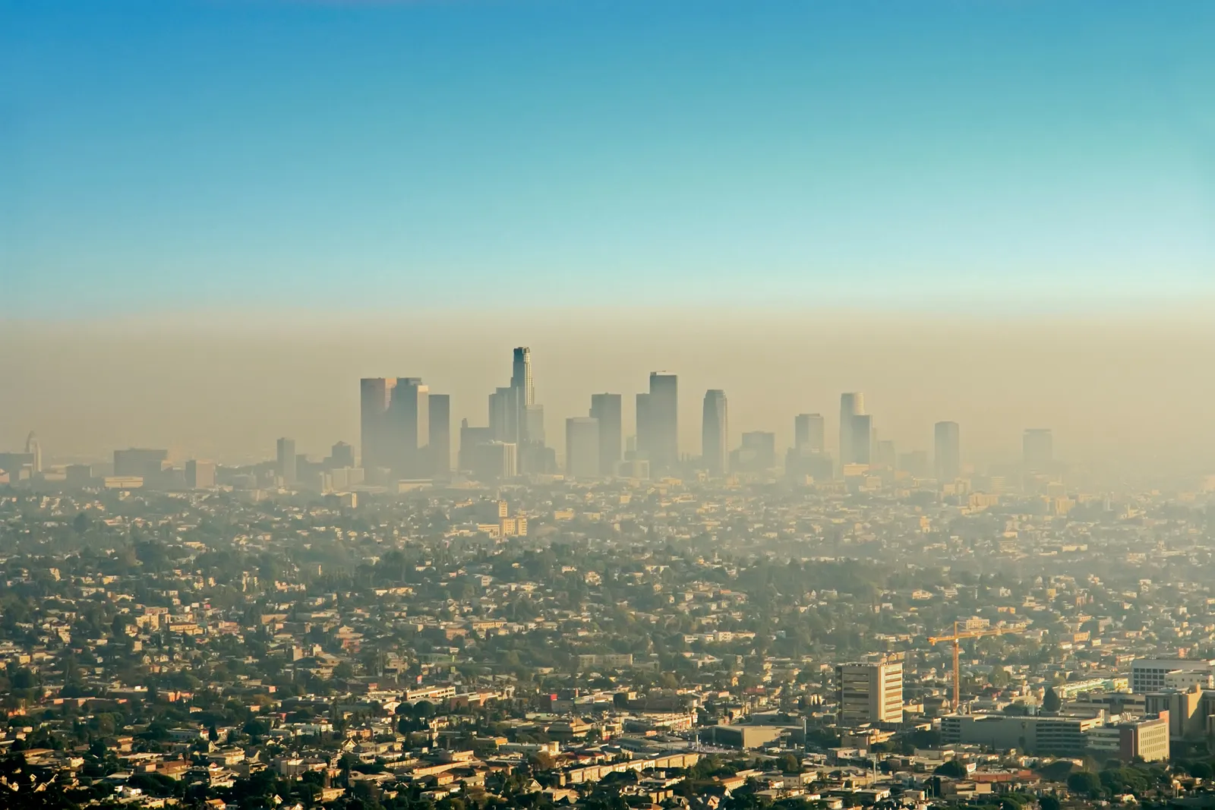

2. **Photolysis of NO₂:**

NO₂ absorbs UV light and breaks down, producing a highly reactive oxygen atom.

*NO₂ (g) → NO (g) + [O](g)*

3. **Formation of Ozone (O₃):**

The atomic oxygen ([O]) reacts with oxygen molecules to form ozone. *O₂(g) + [O] (g) → O₃(g)*

4. **Reaction with Hydrocarbons (VOCs):**

Unburned hydrocarbons react with the atomic oxygen ([O]), forming organic radicals.

*Hydrocarbon (g) + [O](g) → RCO•(g)*

5. **Formation of Peroxyacyl Radicals:**

The organic radicals react with oxygen to form peroxyacyl radicals. RCO•(g) + O₂ (g) → RC(O)O₂•(g)

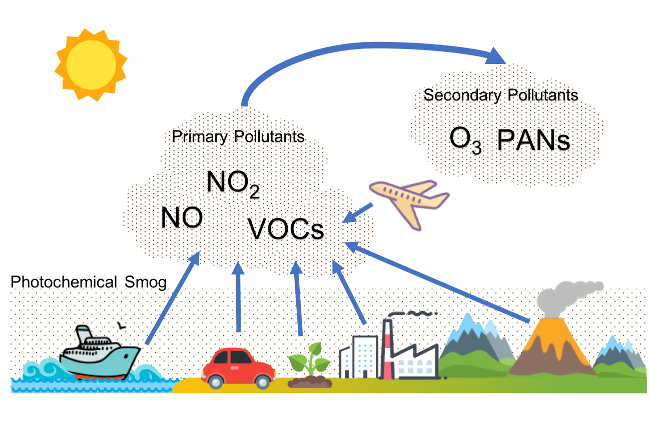

6. **Formation of PAN:**

The peroxyacyl radical reacts with NO₂ to form PAN.

*RC(O)O₂•(g) + NO₂(g) → RC(O)O₂NO₂(g)*

**Properties & Role of PAN:**

∙ Stable at low temperatures and can travel long distances.

∙ Acts as a reservoir for NOₓ and organic radicals, releasing them in warmer conditions, which sustains and prolongs smog formation.

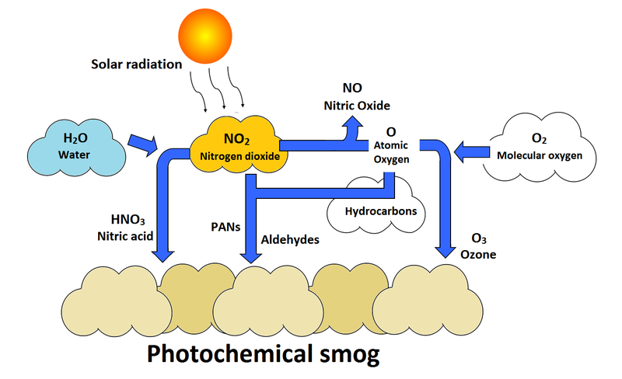

**7.2. Acid Rain**

*Rain with a pH less than 5, caused by the dissolution of acidic gases (SO₂ and NOₓ) in rainwater, forming H₂SO₄ and HNO₃.*

**Primary Pollutants:**

**Sulphur Dioxide (SO₂):** From burning fossil fuels.

**Nitrogen Dioxide (NO₂):** From automobile exhaust.

**7.2.1. Role of Nitrogen Oxides (NO and NO₂) in Acid Rain**

**7.2.2. Direct Role in Acid Rain**

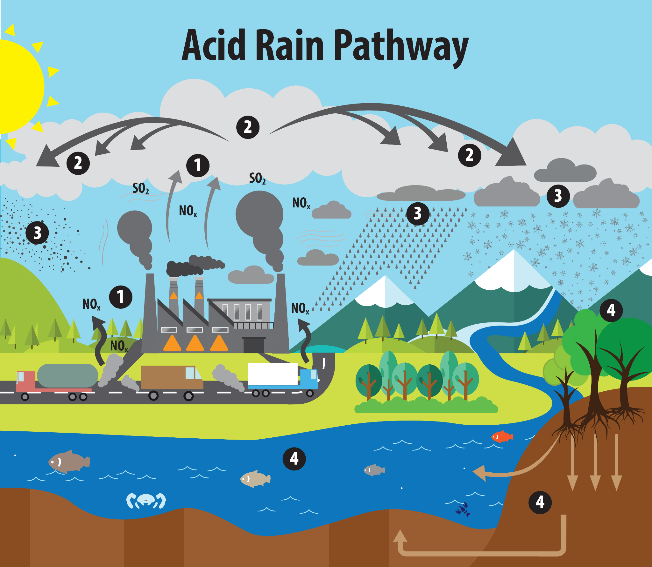

**A) Direct Role: Formation of Nitric Acid (HNO₃)**

1. **Oxidation of NO to NO₂:**

*2NO(g) + O₂(g) → 2NO₂(g)*

2. **Formation of Nitric Acid:**

NO₂ reacts with water and oxygen in the atmosphere.

*4NO₂(g) + 2H₂O(l) + O₂(g) → 4HNO₃(aq)*

**B) Catalytic Role: Oxidation of Sulphur Dioxide (SO₂)**

NO₂ acts as a **catalyst** to convert SO₂ into sulphuric acid (H₂SO₄), a stronger acid. 1. **Oxidation of SO₂ to SO₃:**

NO₂ oxidizes SO₂, producing SO₃ and being reduced back to NO.

*SO₂(g) + NO₂(g) → SO₃(g) + NO(g)*

2. **Formation of Sulphuric Acid:**

SO₃ readily dissolves in water to form H₂SO₄.

*SO₃(g) + H₂O(l) → H₂SO₄(aq)*

3. **Regeneration of the Catalyst (NO₂):**

The NO produced is re-oxidized by atmospheric oxygen, continuing the cycle.

*2NO(g) + O₂(g) → 2NO₂(g)*

**7.3.3. Overall Impact:**

A small amount of NO₂ can catalyze the conversion of a large amount of SO₂ into sulphuric acid, significantly increasing the acidity of rain.

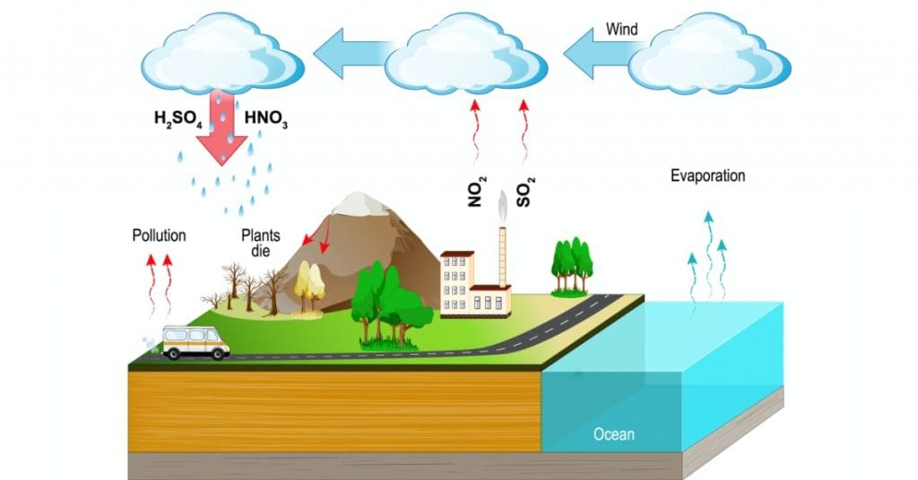

**7.3. Contact Process (Manufacture of Sulphuric Acid)**

**Importance:** Sulphuric acid (H₂SO₄) is a vital industrial chemical used in fertilizers, plastics, explosives, paints, and textiles, earning it the name "King of Chemicals."

**Core Reaction:** The process is based on the catalytic oxidation of Sulphur Dioxide (SO₂) to Sulphur Trioxide (SO₃).

*2SO₂ (g) + O₂ (g)* ⇌ *2SO₃ (g) + 45.2 kcal*

This reaction is **reversible** and **exothermic**.

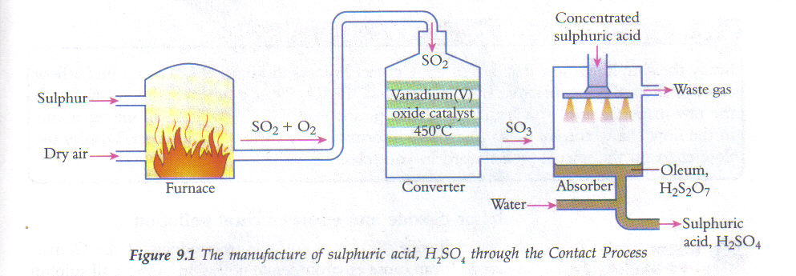

**Optimum Conditions (based on Le Chatelier's Principle):**

**Catalyst:** Vanadium pentoxide (V₂O₅)

**Temperature:** ~450°C (A compromise; low temperature favors yield but high temperature is needed for a practical reaction rate).

**Pressure:** Around 2 atm (200 kPa). A higher pressure favors the side with fewer gas molecules, but only moderate pressure is needed for a good yield.

**Step-by-Step Process:**

1. **Production & Purification of SO₂:**

SO₂ is produced by burning sulphur or roasting sulphide ores.

S(s) + O₂ (g) → SO₂ (g)

The gas is cooled, filtered through coke, and dried.

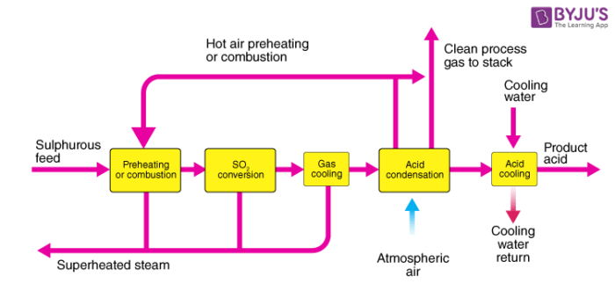

2. **Conversion to SO₃:**

The purified SO₂ and air are passed over a V₂O₅ catalyst in a converter at ~450°C and 2 atm.

2SO₂ (g) + O₂ (g) → 2SO₃ (g)

3. **Absorption & Production of H₂SO₄:**

SO₃ is **not** directly dissolved in water as it forms a corrosive mist. Instead, SO₃ is absorbed into 98% sulphuric acid to form **Oleum (H₂S₂O₇)**.

H₂SO₄ (l) + SO₃ (g) → H₂S₂O₇ (l)

Oleum is then diluted with water to produce concentrated sulphuric acid of any desired concentration.

H₂S₂O₇ (l) + H₂O (l) → 2H₂SO₄ (l)

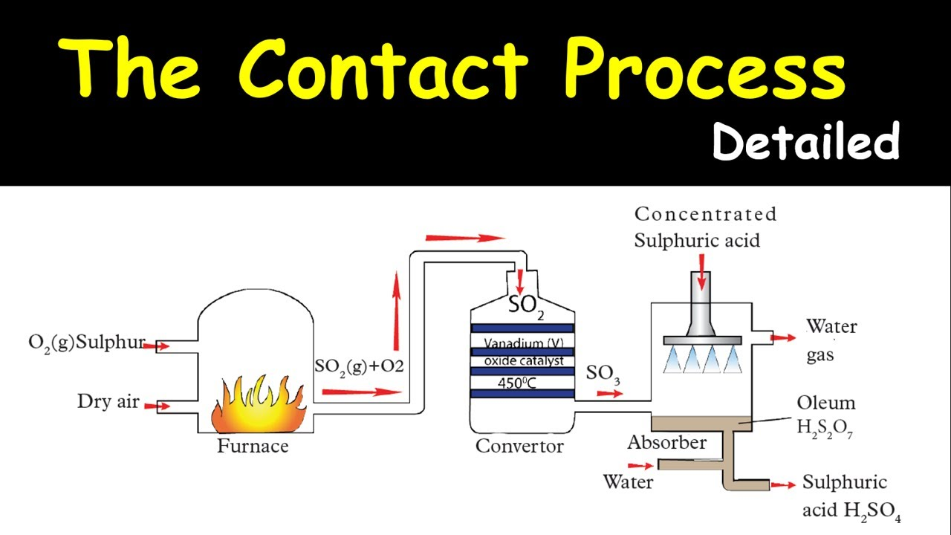

**7.4. Haber Process (Manufacture of Ammonia)**

**Purpose:** Commercial production of Ammonia (NH₃) by fixing atmospheric nitrogen.

**Core Reaction:**

N₂ (g) + 3H₂ (g) ⇌ 2NH₃ (g) + Heat

This reaction is **reversible**, **exothermic**, and results in a **decrease in volume**.

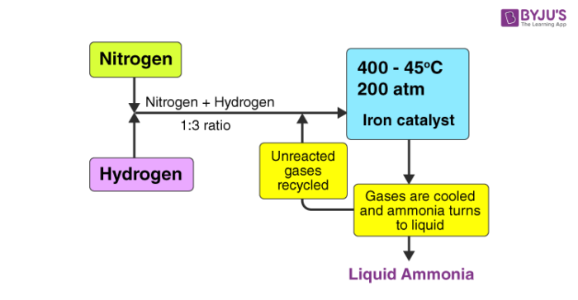

**Sources of Reactants:**

**Nitrogen (N₂):** Obtained from air.

**Hydrogen (H₂):** Obtained from the decomposition of methane (natural gas). **Optimum Conditions (based on Le Chatelier's Principle):**

1. **Pressure: High pressure (200-500 atm)**. This favors the forward reaction because it decreases the total number of gas molecules.

2. **Temperature: Moderately low (450°C)**. Although low temperature favors the exothermic reaction, a higher temperature is used with a catalyst to achieve a practical reaction rate.

3. **Catalyst:** Iron promoter with Molybdenum (Fe/Mo).

4. **Reactant Ratio:** A 1:3 volume mixture of N₂ to H₂. An excess of N₂ is used to shift the equilibrium to the right.

**Process Flow:**

1. Purified N₂ and H₂ gases are mixed, compressed, and passed over the catalyst in a heated chamber.

2. The product gas mixture (containing 10-12% ammonia) is cooled.

3. Ammonia gas is liquefied in a condenser using refrigerated brine and separated.

4. The unreacted N₂ and H₂ are **recycled** back to the reactor to improve overall yield.

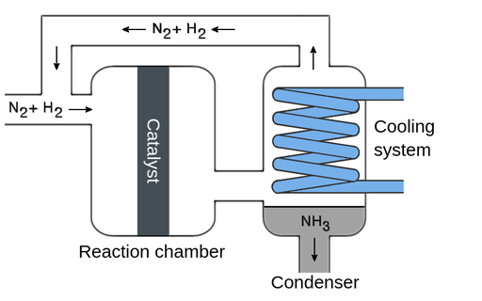

**7.5. Oxides**

Binary compounds of an element with oxygen.

**Classification:**

**1. Acidic Oxides**

Oxides of **non-metals**.

**Behavior:**

React with water to form an **acid**.

React with bases to form salt and water.

**Examples:**

**SO₂:** SO₂ (g) + H₂O (l) → H₂SO₃ (aq) (Sulphurous acid)

**CO₂:** CO₂ (g) + H₂O (l) → H₂CO₃ (aq) (Carbonic acid)

**2. Basic Oxides**

**Nature:** Oxides of **metals**.

**Behavior:**

React with water to form a **base** (if soluble).

React with acids to form salt and water.

**Examples:**

**CaO** CaO(s) + H₂O (l) → Ca(OH)₂(aq) (Calcium hydroxide, a base) **Na₂O & CaO with Acid:**

Na₂O(s) + 2HCl (aq) → 2NaCl (aq) + H₂O (l)

CaO(s) + 2HCl (aq) → CaCl₂ (aq) + H₂O (l)

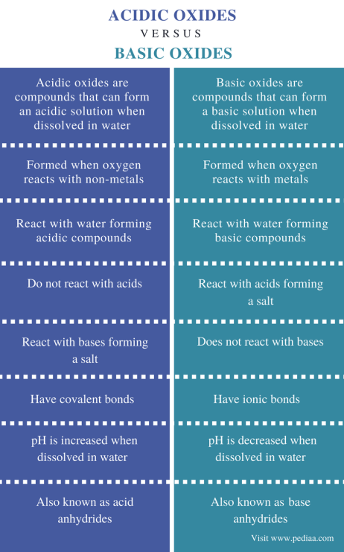

**Amphoteric Oxides & Metal Reactivity**

**Amphoteric Oxides**

Oxides that can react with **both acids and bases**. They are typically oxides of certain metals.

**Behavior:** They display dual (acidic and basic) character.

**Examples:**

**Aluminum Oxide (Al₂O₃)**

With Acid: Al₂O₃(s) + 6HCl (aq) → 2AlCl₃ (aq) + 3H₂O (l) (Behaves as a base)

With Base: Al₂O₃(s) + 2NaOH (aq) + 3H₂O (l) → 2NaAl(OH)₄ (aq) (Sodium aluminate) (Behaves as an acid)

**Zinc Oxide (ZnO)**

With Acid: ZnO(s) + 2HCl (aq) → ZnCl₂ (aq) + H₂O(l) (Behaves as a base)

With Base: ZnO(s) + 2NaOH (aq) + H₂O (l) → Na₂[Zn (OH)₄](aq) (Sodium zincate) (Behaves as an acid)

**7.5. General Characteristics of Metals**

Metals react with various substances, and their reactivity determines the products. **Reaction with Dilute Acids**

Metal + Dilute Acid → Salt + Hydrogen Gas

**Example:** Mg(s) + 2HCl (aq) → MgCl₂ (aq) + H₂ (g)

**Observations:**

**Very Reactive (K, Na):** React explosively.

**Moderately Reactive (Mg, Zn, Fe):** React steadily, producing bubbles of H₂.

**Less/Unreactive (Cu, Ag, Au): No reaction.**

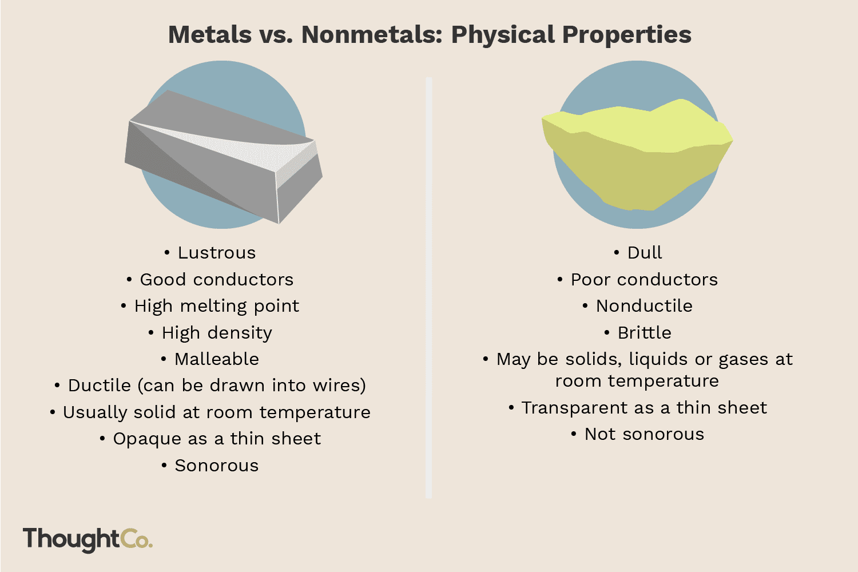

**2. Reaction with Cold Water**

Metal + Cold Water → Metal Hydroxide + Hydrogen Gas

**Example:** 2Na(s) + 2H₂O (l) → 2NaOH (aq) + H₂ (g)

**Observations:**

**Very Reactive (K, Na, and Ca):** React vigorously.

**Moderately Reactive (Mg):** Reacts slowly; faster with hot water. **Less Reactive (Zn, Fe):** Do not react significantly.

**3. Reaction with Steam**

Metal + Steam → Metal Oxide + Hydrogen Gas

**Example:** 3Fe(s) + 4H₂O(g) → Fe₃O₄(s) + 4H₂(g)

**Observations:**

**Very Reactive (K, Na):** Not tested (too violent).

**Moderately Reactive (Mg, Zn, Fe):** React readily.

**Less Reactive (Cu): No reaction.**

**4. Reaction with Oxygen**

Metal + Oxygen → Metal Oxide

**Example:** 2Mg(s) + O₂ (g) → 2MgO(s)

**Observations:**

**Very Reactive (K, Na):** React rapidly, may form peroxides/superoxide.

**Moderately Reactive (Mg, Al):** Form a protective oxide layer that prevents further reaction.

**Less Reactive (Cu):** Oxidizes slowly, forming a patina.

**Unreactive (Au, Pt): No reaction** under normal conditions.

**7.5.1. The Reactivity Series**

Metals can be arranged in order of decreasing reactivity based on their reactions with water, steam, and acids.

Potassium > Sodium > Calcium > Magnesium > Aluminum > Zinc > Iron > Lead > Copper > Silver > Gold

**Four Main Groups:**

**1. Highly Reactive Metals (e.g., K, Na, Ca)**

**Cold Water:** React vigorously to form metal hydroxide and H₂ gas. **Steam & Acids:** React explosively.

**2. Moderately Reactive Metals (e.g., Mg, Al, Zn, Fe)**

**Cold Water:** Slow or no reaction.

**Steam:** React to form metal oxide and H₂ gas. (e.g., Mg(s) + H₂O (g) → MgO(s) + H₂ (g)

**Acids:** React steadily with acids to form salt and H₂ gas.

**3. Less Reactive Metals (e.g., Pb, Cu, Ag)**

**Cold Water & Steam:** No reaction.

**Acids:** React slowly or not at all (e.g., Cu and Ag do not react with dilute acids).

**4. Unreactive Metals (e.g., Au, Pt)**

**Cold Water, Steam, & Acids:** No reaction under normal conditions.

